Alexander Lizzo

Internetworking 307

Professor John Ringel

*Internetworking Class 1 -* Jan 23th 2020

OSI Model:

7.Application Layer

6. Presentation Layer

5. Session Layer -

4. Transport Layer – Transmission Control Protocol /User Diagram Protocol (UDP)

3. Network Layer

2. Data Link

1. Physical Link

TCP/IP Model:

5. Application level (which covers 7,6,5 in the OSI model)

4. Transport

3. Network – IP address

2. Data layer

1. Physical level

Network mapping:

Square with an “x” in the center is a switch

Circle with an “x” in the middle is a router

Straight line - Through line

Dotted line -- Cross over cable

Squiggly line – WAN cable

Shielded Twisted Pair (STP)

Unshielded Twisted Pair (UTP)

Through cable – one device to another kind

Crossover cable – to like devices.

Optics:

Multi mode

Single mode

Computer hubs – antiquated machine that can generate loops. The hub receives a packet and send the packet out of every port in the machine.

WAN – wide area network

PAN – personal area networks

MAN – metropolitan area network. (city wide - one provider)

LAN – local area network

Port on desk

1 connects to router

2 connects to switch

3 LAN connection

4 empty

5 empty

6 internet connections

TCP/IP Networking Model

Adjacent Layer interactions – refers to the concepts of how adjacent layers in Networking model on the same computer, work together. Ie the higher-level Http wants error recover so it uses the lower level protocol (transport TCP layer).

Same-layer interaction – when a particular layer on the computer want to communicate with the same layer on another computer, the two computers use headers to hold the information they want to communicate.

TCP/IP Model:

5. Application level

HTTP header on packet frame that fetches request from server

4. Transport

TCCP Error recovery Basics

- TCP message is called a segment has a sequence number, when one of those segments fails to deliver then the client computer will request that segment again.

3. Network – IP protocol

2. Data layer -header and tail!

1. Physical level

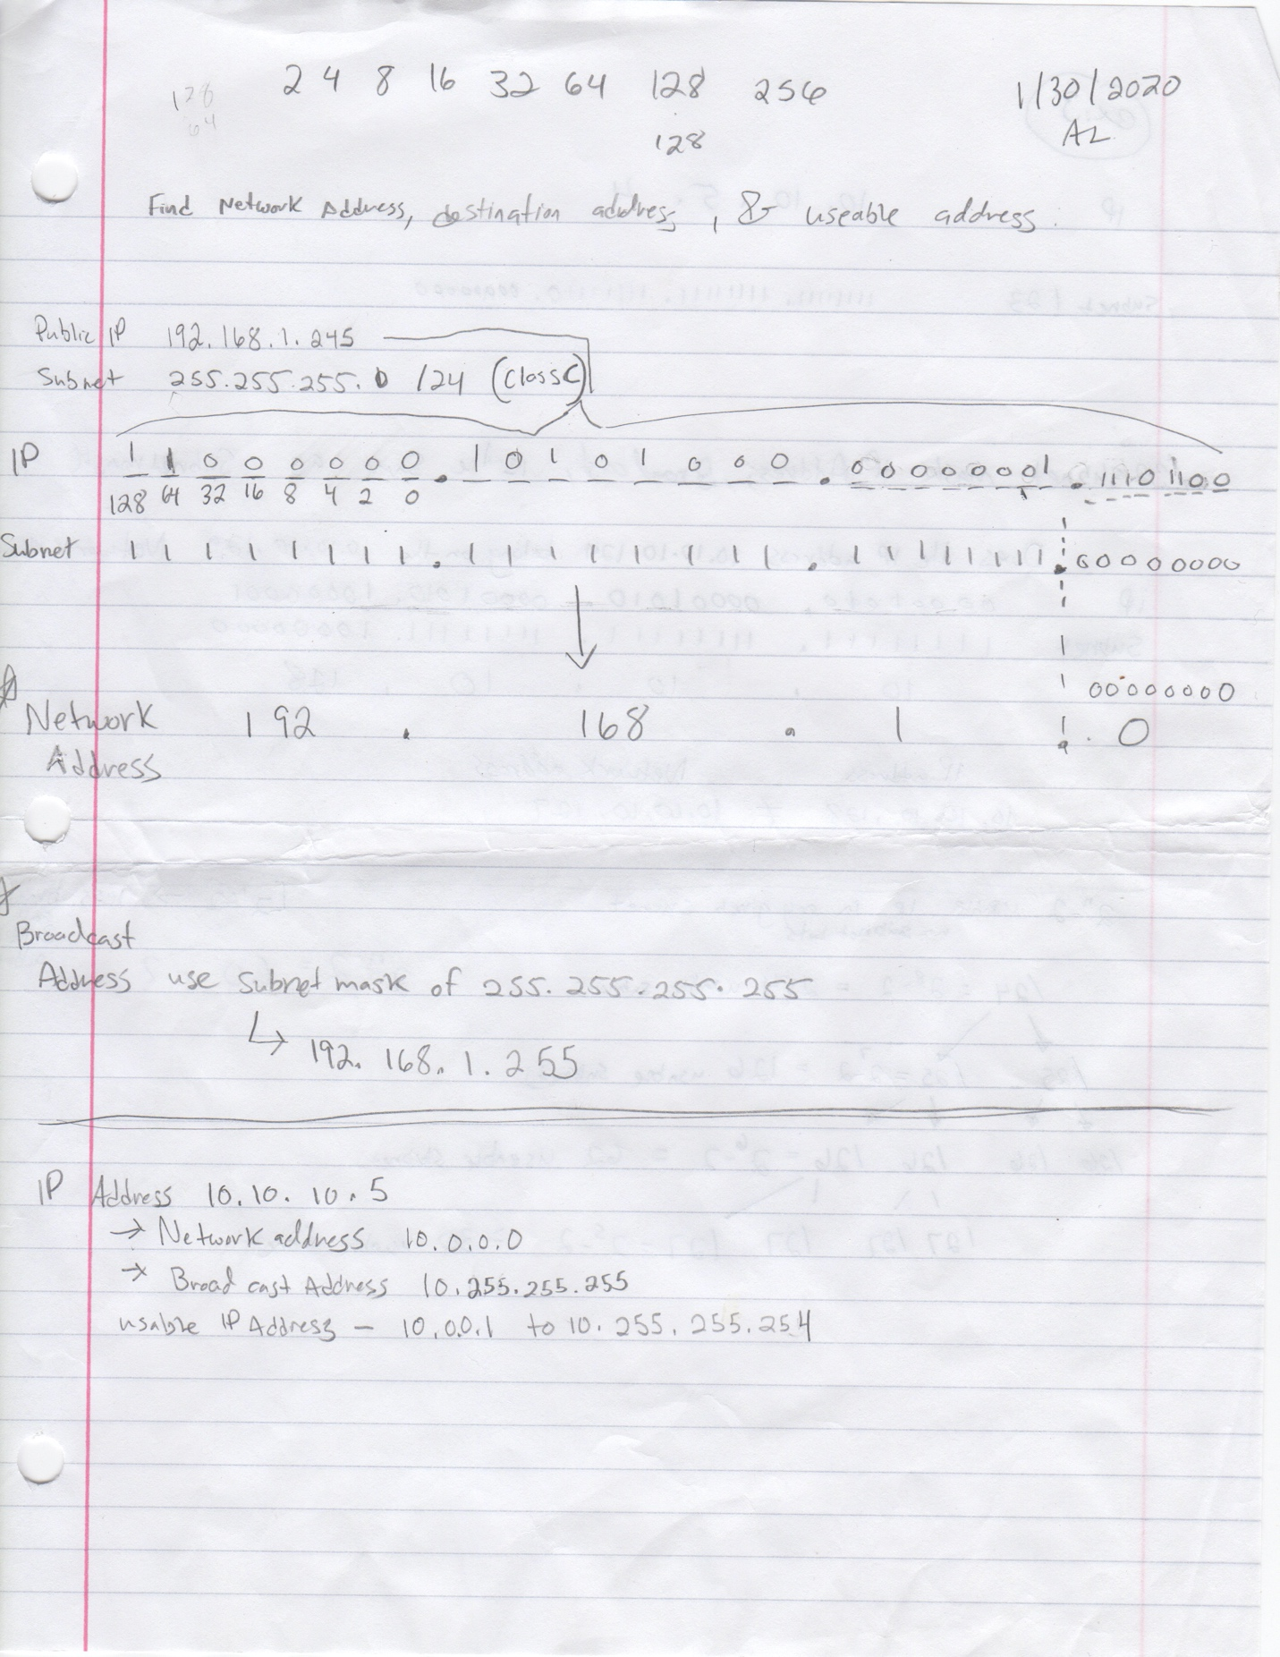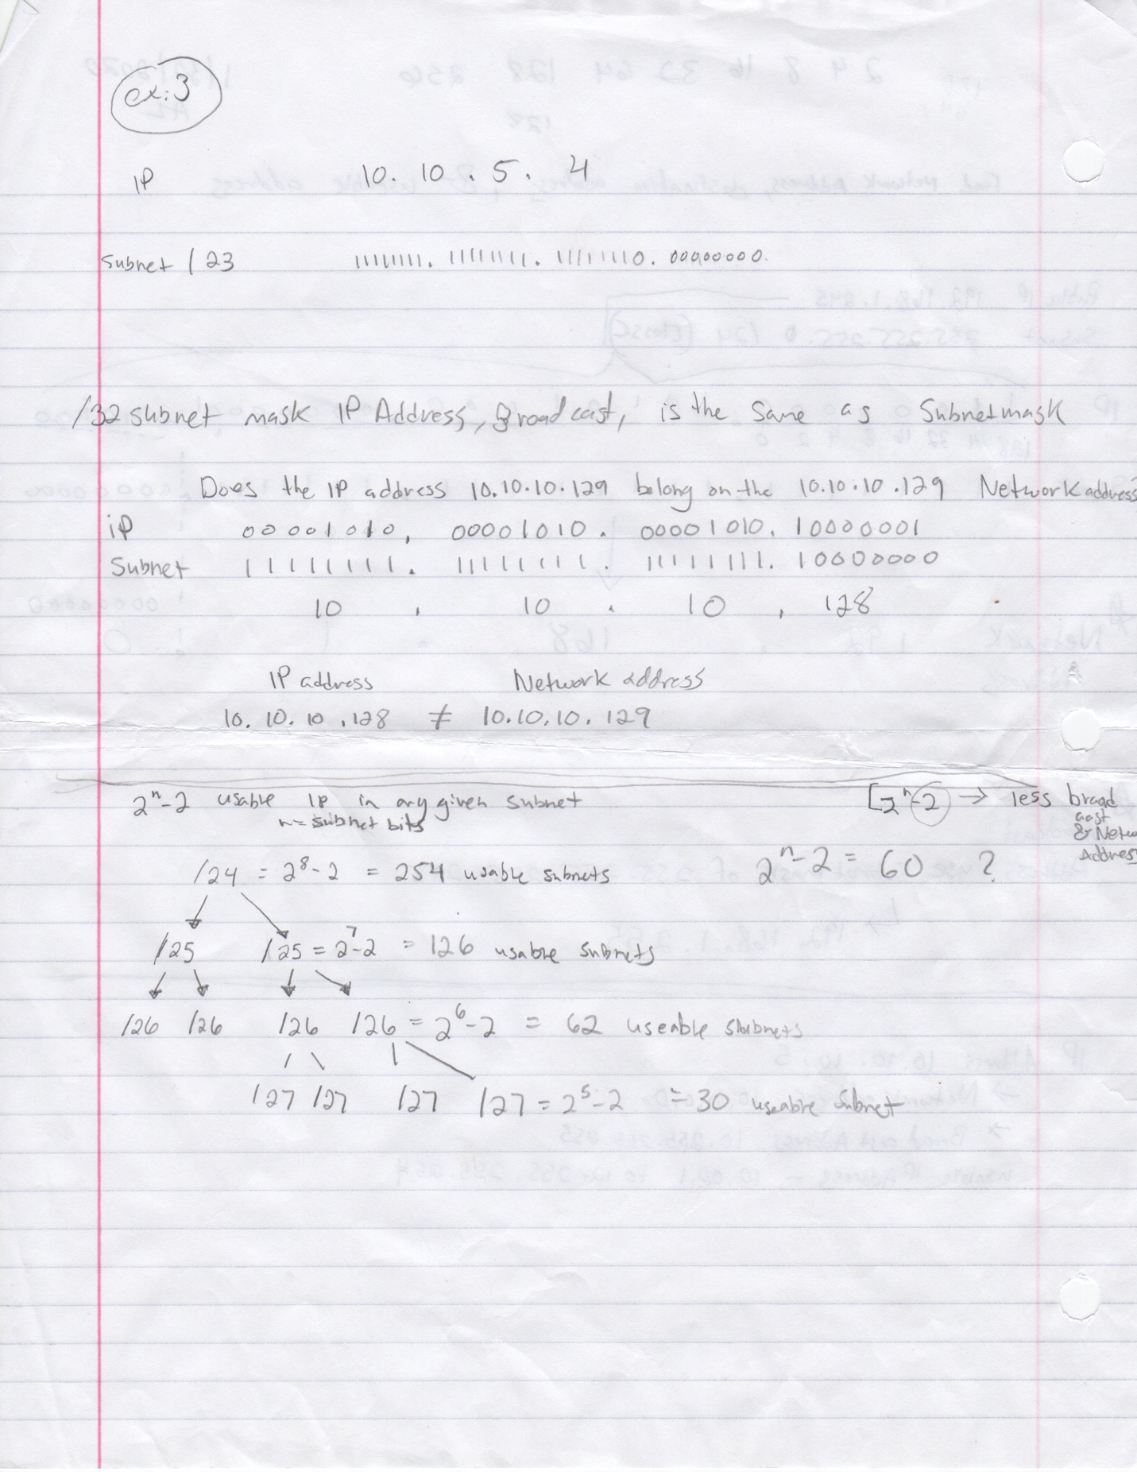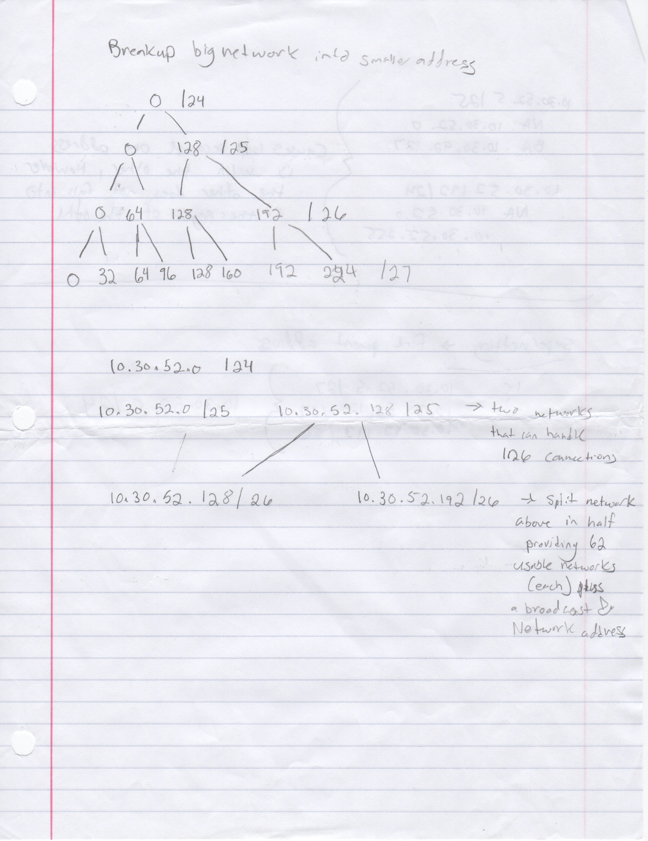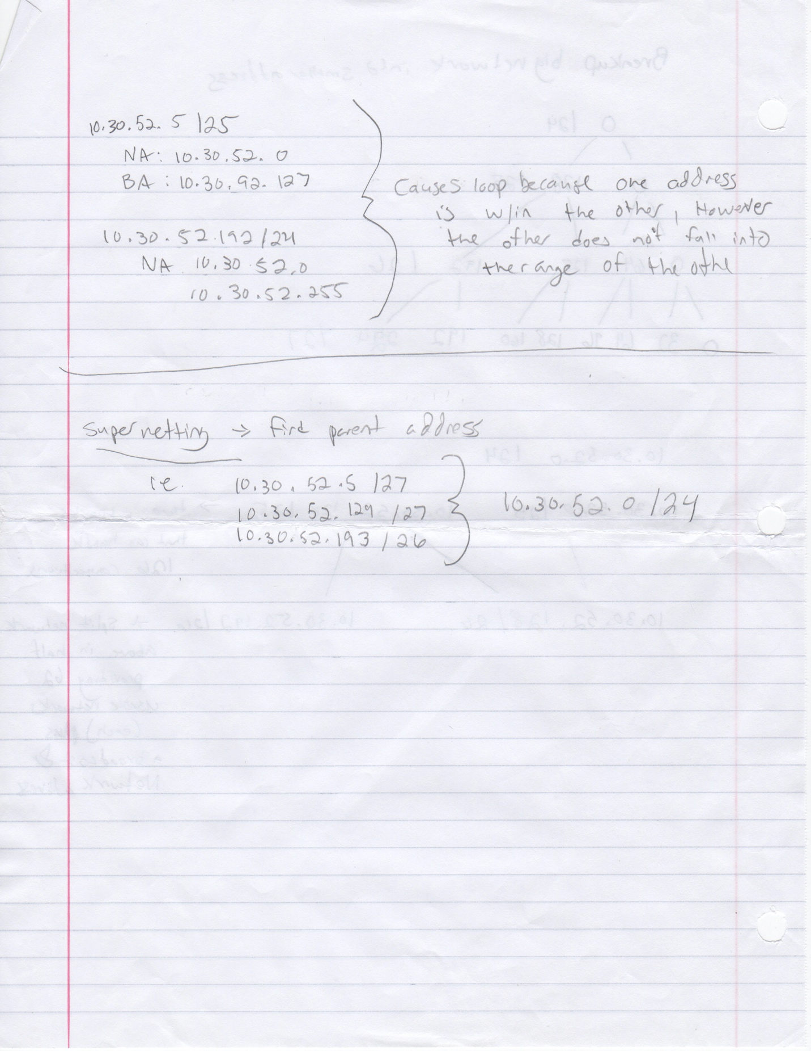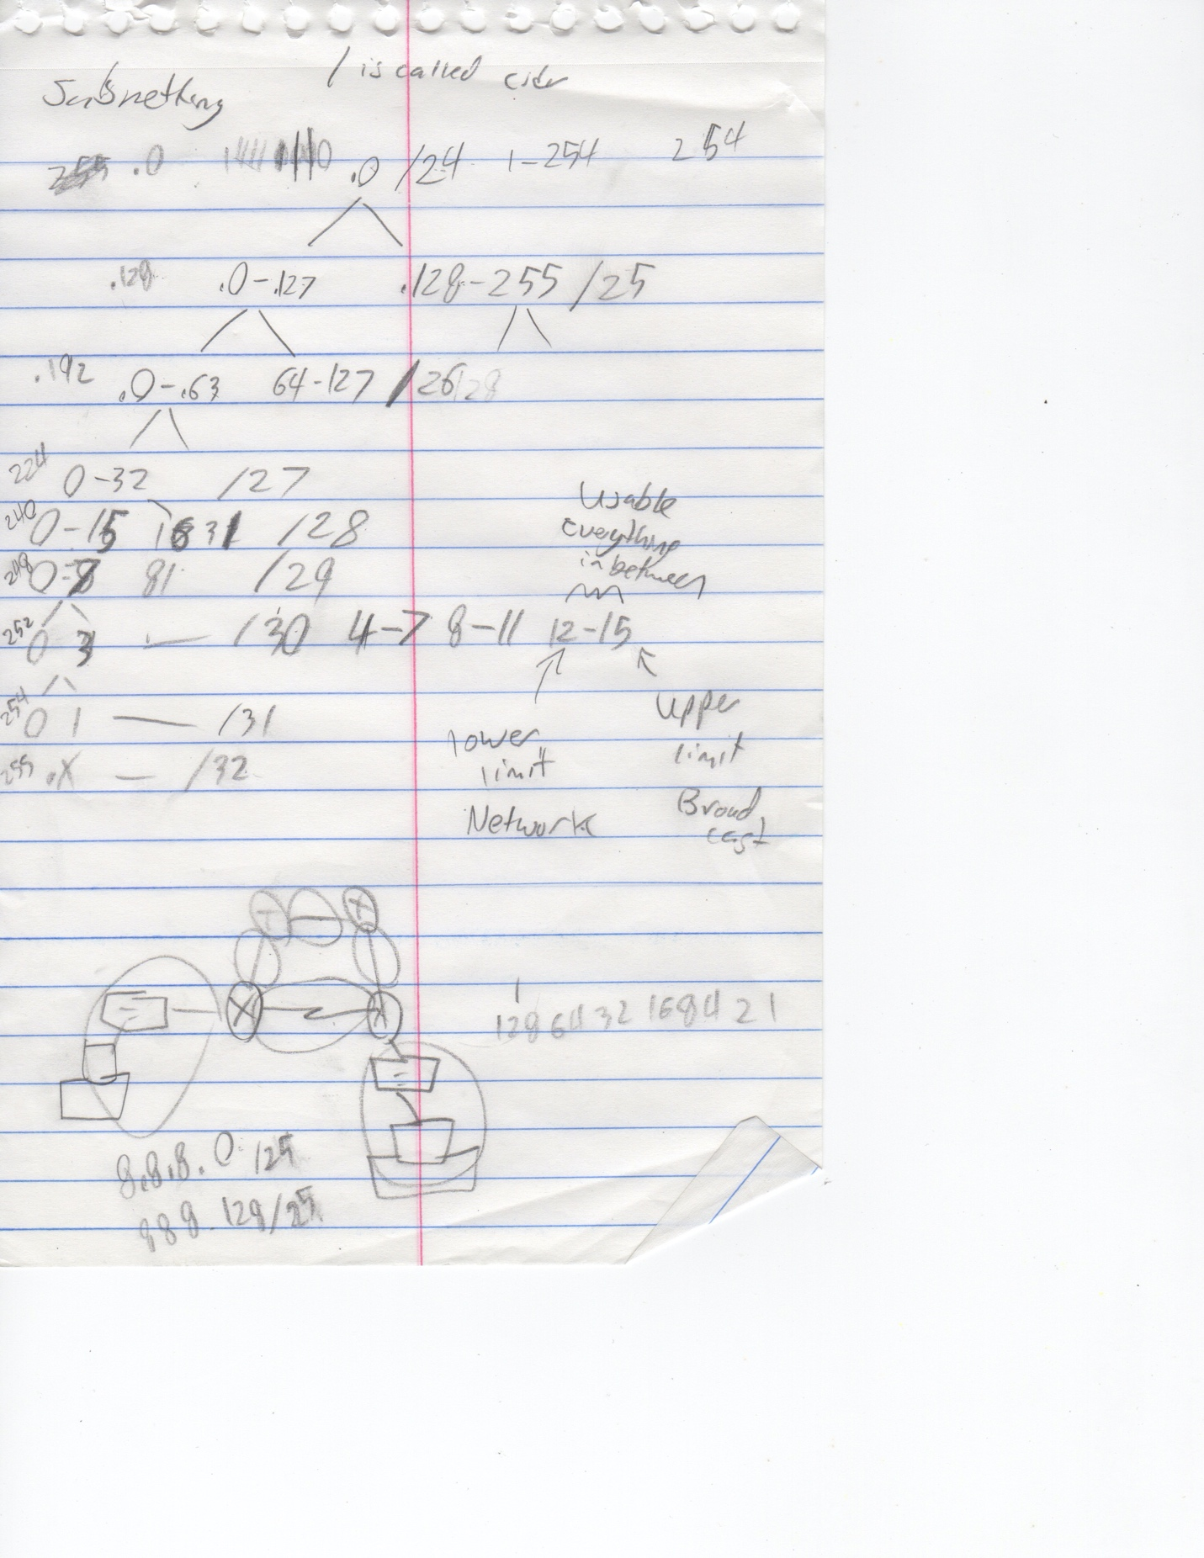

Internetworking Class 2 - January 30th 2020

IP

Public vs private IP

Subnet masks

Class A: 0-128^-1 255.0.0.0

Class B: 128-192^-1 255.255.0.0

Class C: 192 – 224^-1 255.255.255.0

(there are class D and E use for research)

Private class IP address

10.0.0.0 – 10.255.255.255

172.16.0.0 – 172.31.255.255

192.168.0.0 – 168.255.255

Network address will always have an even address(except in /32 subnet masks)

Broad cast address is always odd!

**Banners:**

Router(config)# banner motd # your message of the day goes here#

**Passwords:**

Sw1 (config)# line vty 0 15

Sw1 (config-line)#login local

Sw1 (config-line)#exit

Sw1 (config)# username <username> password <password>

*Class 3: VLAN* – February 6th 2020

VLAN provide security and separation of data.

Trunk line – will allow any packets to pass through regardless of packet specification.

VTP – variable trunking protocol: allows us to set up a master for the other devices. (switch to switch). Let say we have a lot of switches… and you have several Vlan… if you don’t want to configure it on every device you can use VTP which will synchronize all devices to use the same vlan.

Switch> en

Switch# show vtp status (see configuration revision, if zero, then no vtp; 5 default vlans; operating mode is server mode by default; need a VTP domain name)

Switch# show vlan (5 default vlans )

Ie..

Switch1(config)# vlan 11 (create new vlans)

Switch1(config)# vlan 22. (create new vlan)

Switch1# Show vlan

Switch1(config)# vtp domain <some domain name>

Switch1(config)# vtp mode server

Switch1(config-int)# switchport mode trunk

Switch1(config-int)# switchport trunk allowed vlan 1-99

**…the switch that is set as client will learn the vlans from the server (no need to configure vlans on switch 2)**

Switch2(config)# vtp domain <same domain name as switch 1>

Switch2(config)# vtp mode client

To confirm

Switch2# show vtp status

🡪 number of existing vlans > 5

🡪 VTP operating mode is client

🡪 Vtp domain name should change and be the same as switch1

Switch2# show vlan

🡪 should see the vlans from the server switch

Spanning tree - that prevents loops (complicated formula to determine the best device to route traffic) every 30 to 45 seconds the STP will automatically send an STP frame to verify the best route and determine loops – and send information accordingly.

**Vlan Setup on Cisco Switches:**

**Name vlan**

En > config T > Vlan # > name VlanName

**Verify vlan**

Show vlan brief

**Set access mode:**

En > config t> interface Port# > switchport mode access/trunk

**Set access mode for Vlan:**

En > config t> interface Port# > switchport access vlan#

Or…

Switch(config)# Vlan #

Switch(config-vlan)# name <vlan name>

Switch(config-vlan)# vlan #

Switch(config-vlan)# name <vlan name>

Switch# Show vlan

Switch(config t)# int <port number>. Port on switch connected to the PC

Switch(config- if)# switchport mode access

Switch(config- if)# switchport access vlan # // should correspond to the vlan set ealier.

Switch# Show run. // should see the vlan on the port

Switch# Show vlan // port assignments

//different vlans on the same switch without a router will not communicate with eachother.

… telenet config

Switch(config t)# int vlan #. /// this command is used to access an existing vlan so you can put an ip address on the device

Switch(config if)# ip add <ip> <subnet>

Switch(config if)# no shut

Switch(config)# line vty 0 15

Switch(config-line)# password <any password>. //telnet password to communicate remotely

Switch(config-line)# login.

Switch(config )#. Enable secret <any password>. // allows remote administration and allows past enable mode.

…

**Trunk portson switch** can carry multiple Vlan across a single physical cable…

Here are the commands:

(do to both sides…)

Switch(config t)# int <port>

Switch(config if)# switchport mode trunk

Switch(config if)# switchport trunk allowed vlan 1-99 (or any vlan #)

Switch# show run

Test with Switch# show interface trunk

Class 4: (Routing) 2/13/2020

Cisco Switch ports are normal open to communicate with any device on the device. Routers are the exact opposite. Every interface needs it’s own ip address.

Setting static IP address in CLI on cisco routers: you must be in global config type in:

IP Route *some ip address*

Static routes

Router(config)# ip route 172.16.20.0 255.255.255.0 172.16.10.2

-To get to the destination network of 172.12.20.0 with sub net mask 255.255.255.0, send all packets to 172.16.10.2. where 172.16.20.0 = destination net; 255.255.255.0 is the subnt; 172.16.10.2 is the net-hop address

Router(config)# ip route 172.16.20.0 255.255.255.0 serial 0/0/0

-. where 172.16.20.0 = destination net; 255.255.255.0 is the subnt; s0/0/0 exit interface

*Class 4 Routing Protocols OSPF & Sub interfaces - 2/20/20.*

*OSPF:*

*Inverse binary relationship*

*Routers only care about what is connect to it.*

*Open Shortest Path First*

* edgeRouter (config-t)# Router ospf 1
* edgeRouter (config-router)#Network <ip address of connected network> <inverse subnet mask> area 0
* edgeRouter (config-router)# Default-information originate
* edgeRouter (config)# ip route 0.0.0.0 0.0.0.0 <ip address of the outbound port to ISP

R1# Show ip route (this will allow you to verify the connection)

**default-information originate** command will send ospf information to other routers connected to device. Used on the edge router connected to the ISP. Only used with OSPF. **IMPORTANT:** this command, default-information originate, it is a substitute for setting default static routes on each of the internal routers (command: ip route 0.0.0.0 0.0.0.0 <ip address of the outbound port to edge router>).

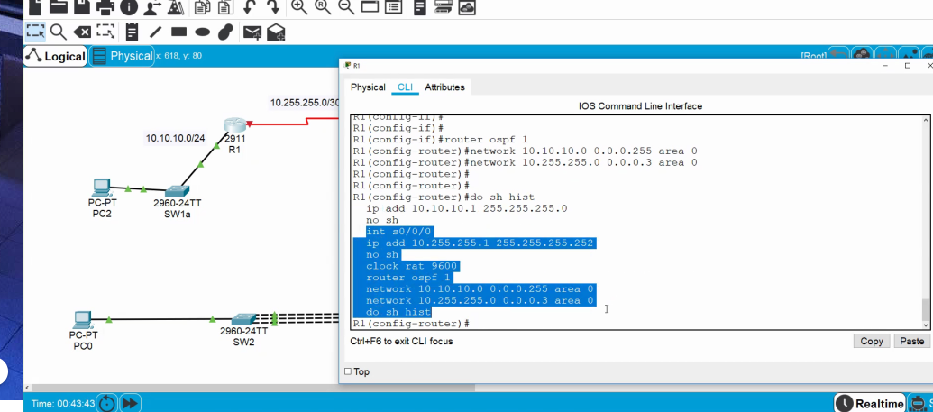

***Configuring sub interfaces, or multiple ip address on one serial port on a router:***

Commands:

* Interface <interface number>. <subinterface number>
* Encapsulation dot1q <vlan id number 1 to 4096>
* IP address <ip address of sub interface> <subnet mask>
* No shutdown

*Helpful Commands:*

*Show IP route*

*On the switch:*

*Commands:*

*Switchport mode access vlan <number corresponding to vlan on router>*

*Spanning-tree port fast*

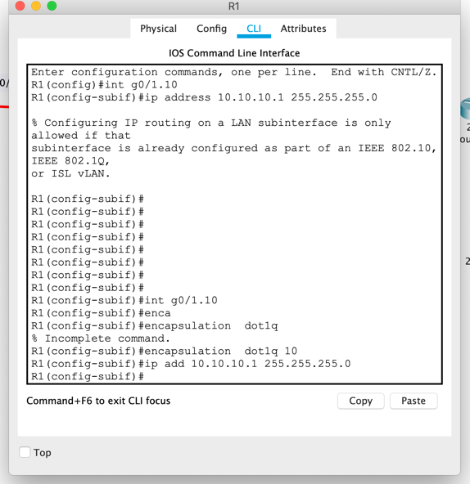

*Sub interface commands*

***Class 5 ACLS*** *- February 27th 2020*

*ACL – Access control lists*

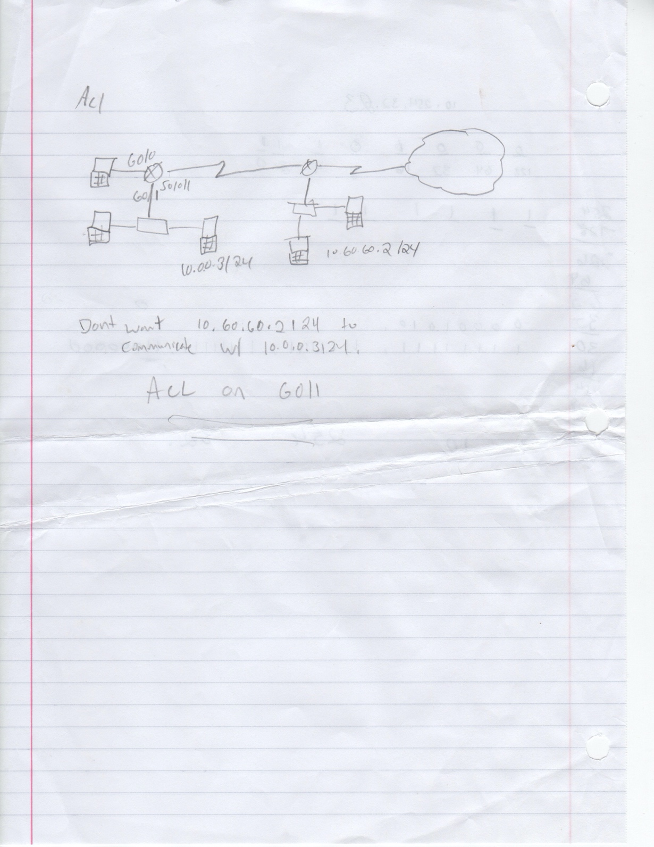

*Out vs IN*

*Standard = 1-99. Checks for IP Address.*

*Extended = 100 -199 check for ports (FTP, Web, etc..)*

*Permit vs deny*

*Rule 1, rule 2, rule 3…. Rule X*

*Where x is the last rule on the list is reserved for deny all option. Deny all is set by default. & rule X-1 is an option for permit any, which is explicitly stated. Each rule is basically an “if-statement.”*

standard is closest to the destination

extended is closest to the source

router(config)# access-list <standard or extend #> <permit/deny> <source IP><wildcard mask>

***To set an access list to an existing port***

commands:

router(config)# access-list <access list number> deny any

router(config-int)# interface <interface in which to apply rule>

router(config-int)# ***Ip access-group 11 in/ out.***

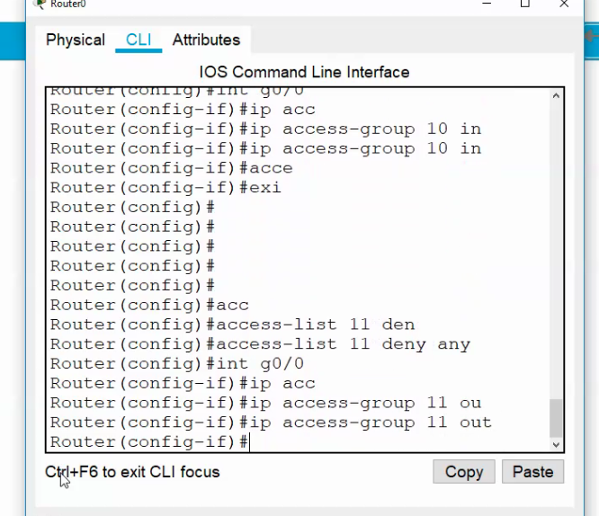

***Class 6*** *- March 5th 2020*

NAT AND PAT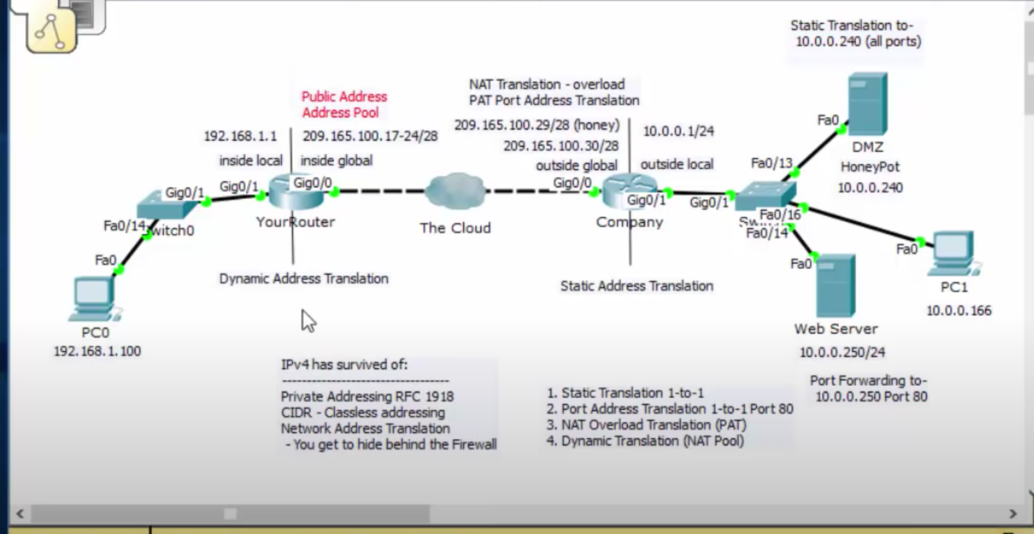

1. Static translations 1 to 1 -- if you have an inside global IP address(port connected to ISP from edge router) that you want to translate to an inside local address, so that if a user from the outside types in that ip address they can reach in inside local server. For this to work you need a few ip addresses from the edge router to the ISP… When the remote user types in the ip address of the ISP inside global the edge router translates that IP address into an internal ip address. 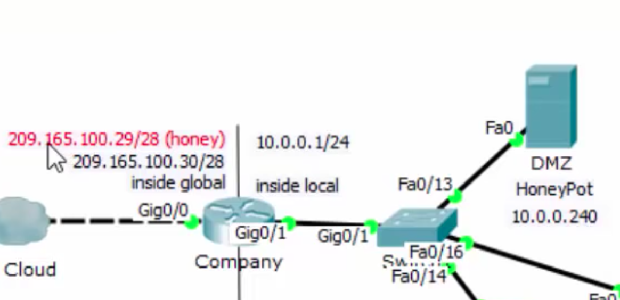

In the above example, the remote user types in 209.165.100.29 and the company router translate that ip address to the DMX honey pot ip address (10.0.0.240). Notice there are two ip address needed on the inside global.

commands:

-router(config)# interface <interface of the port that points to the outside(inside global)

- router(config-if)# ip nat outside

- router(config)# interface <interface of the port that points to the inside>

- router(config-if)# ip nat inside

- router(config-if)# ip nat inside source static translate <ip address inside webserver/pc> <ip address of outside router port>.

^^ ip address translation(no need to specify IP )

The highlighted command should be on the same interface. (this command is passed through on the interface). (this require an additional ip addresses on the outbound port)

To test, type the ip address of the inside global(209.165.100.29) port on the edge router from a remote computer in the web browser.

1. Port Address Translation 1 to 1 using port 80 – only want to access the webserver from port 80. In this case you can use the existing ip address assigned to the inside globals router port.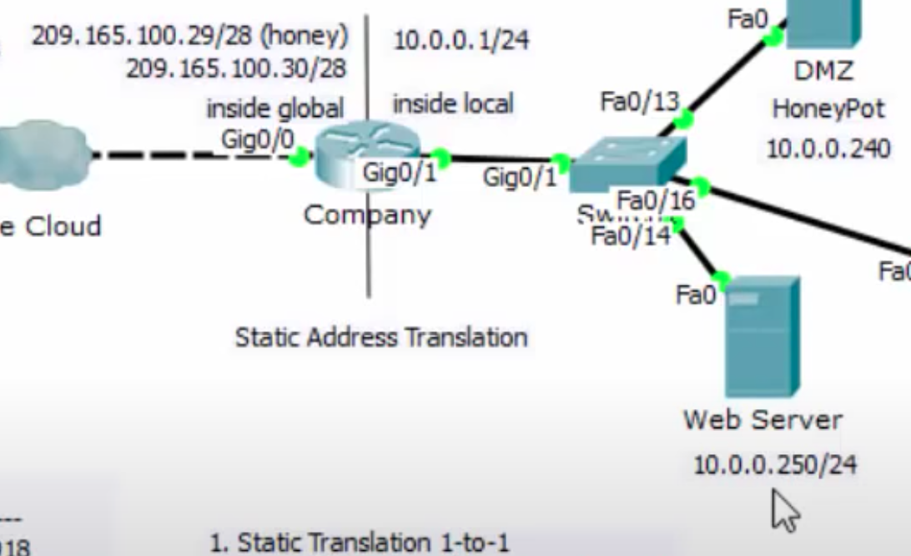

- Commands:

-router(config)# interface <interface of the port that points to the outside(inside global)

- router(config-if)# ip nat outside

- router(config)# interface <interface of the port that points to the inside>

- router(config-if)# ip nat inside

- router(config)# ip nat inside source static tcp <ip address inside webserver/pc(10.0.0.250)> <port(80)> <ip address of outside router port(209.165.100.30)>. <port(80)>

(notice – webserver address must be on a separate ip address )

To test, type the ip address of the inside global(209.165.100.30) port on the edge router from a remote computer in the web browser.

1. NAT overload Translation (Port Address Translation) – (MOST COMMON) general translation. PC user needs to be translated to the inside global address (209.165.100.30) to public address. This is a port address translation (PAT).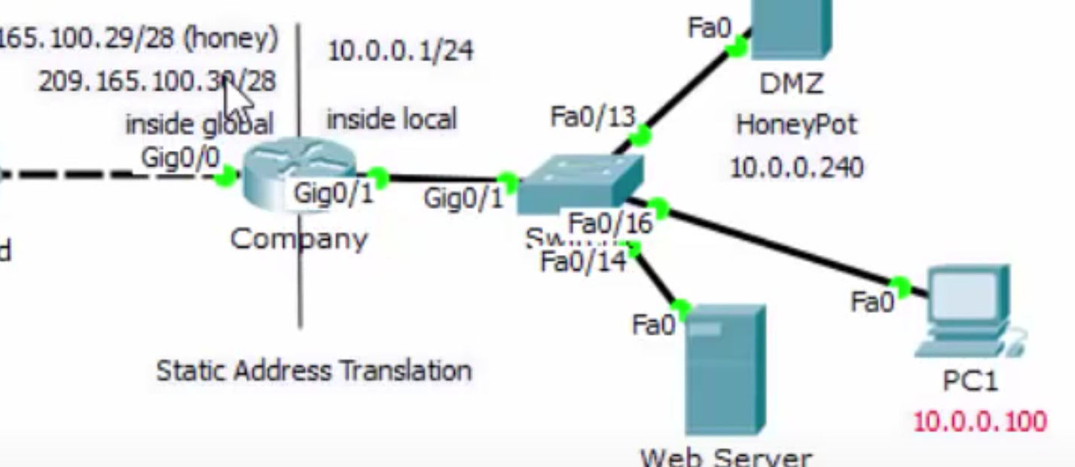

-commands

-router(config)# interface <interface of the port that points to the outside(inside global)

- router(config-if)# ip nat outside

- router(config)# interface <interface of the port that points to the inside>

- router(config-if)# ip nat inside

**set up access list**

- router(config)# access-list ***10*** permit <inside ip address network(10.0.0.0)> <wild card bits – inverse subnet mask(0.0.0.255)>

- router(config)# ip nat inside source list ***10*** interface <interface port number> overload

**To verify translation**

Router# Show ip nat translation

1. Dynamic Translation (NAT POOL)

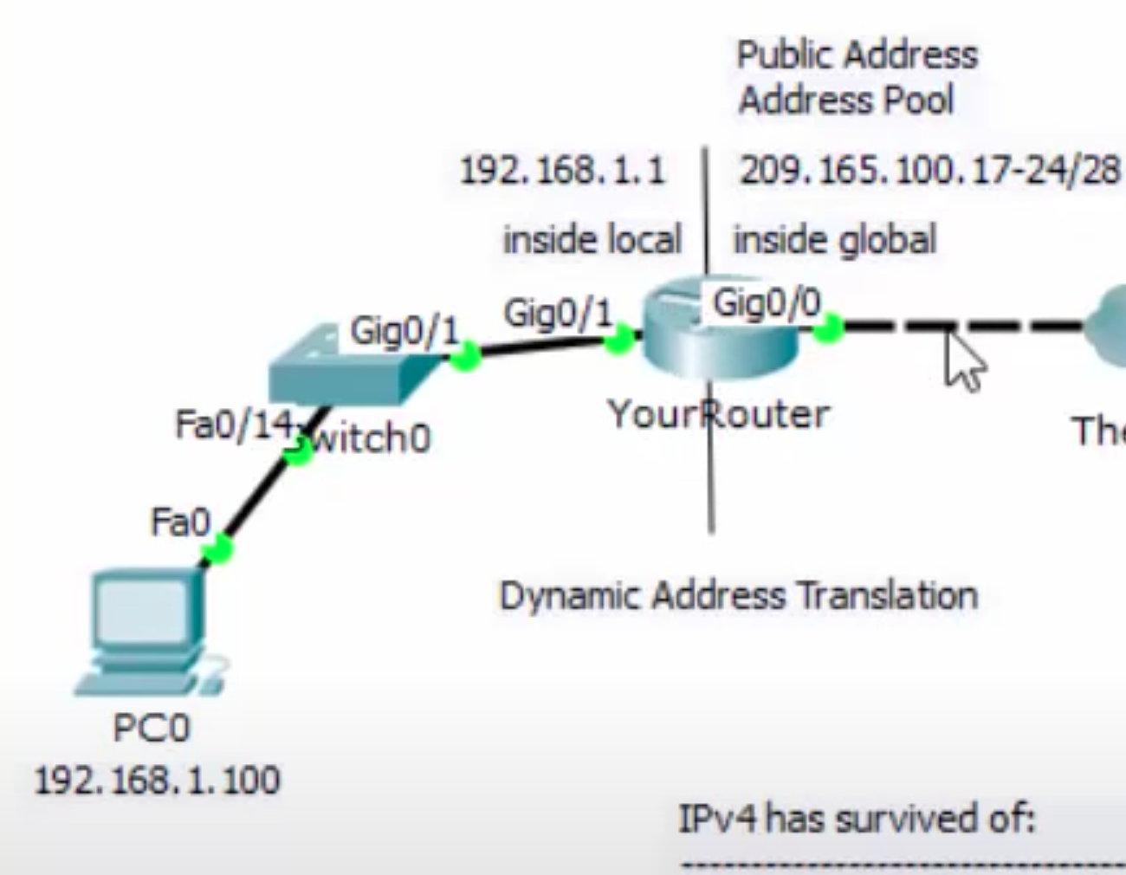  
Network address translation – uses ip address

Port address translation – uses port number between 1 -~65000 the port refers to the port with in the packet

Notice that the other router on the other side has multiple inside global ip addresses. We translate everyone on our private address to a pool of public addresses.

**commands**

-router(config)# interface <interface of the port that points to the outside(inside global)

- router(config-if)# ip nat outside

- router(config)# interface <interface of the port that points to the inside>

- router(config-if)# ip nat inside

**Access-list**

- router(config-if)# access-list ***1*** permit <inside ip address network(192.168.1.0)> <wild card bits – inverse subnet mask(0.0.0.255)>

**Nat Pool**

- router(config)# ip nat pool <some pool name> <start ip address of the edge router to ISP (209.165.100.17)> <end ip address of the edge router to ISP (209.165.100.24)> netmask <sub net of inside global (255.255.255.240 (/28))>

- router(config)# ip nat inside source list 1 pool <poo namel> overload

**To verify translation**

Router# Show ip nat translation

---------------------------------------------------------------------------------------------------------------------

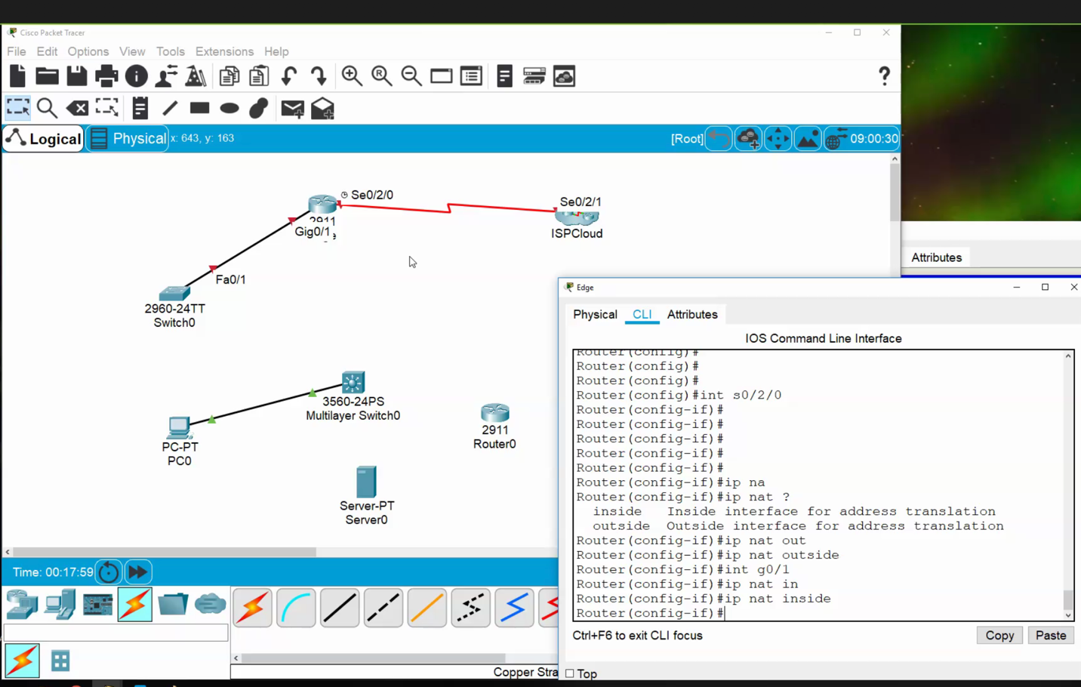

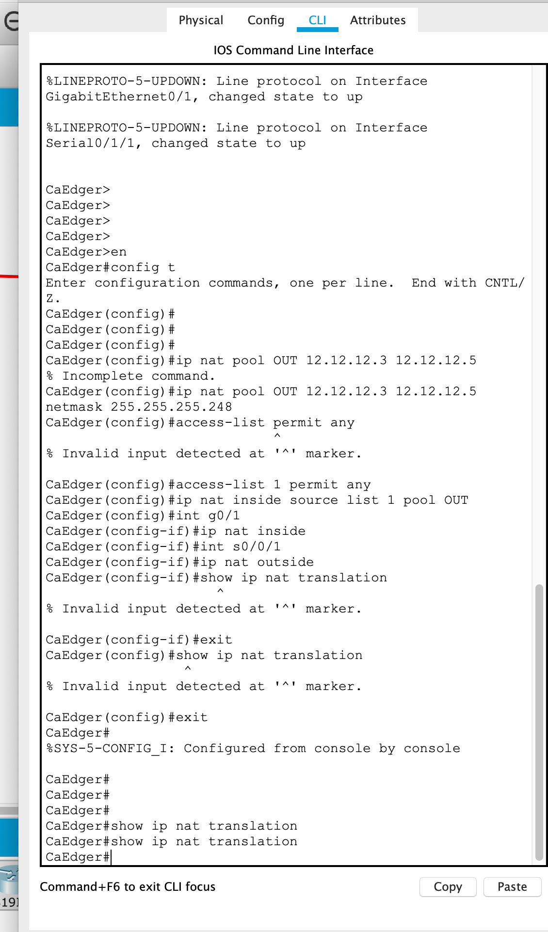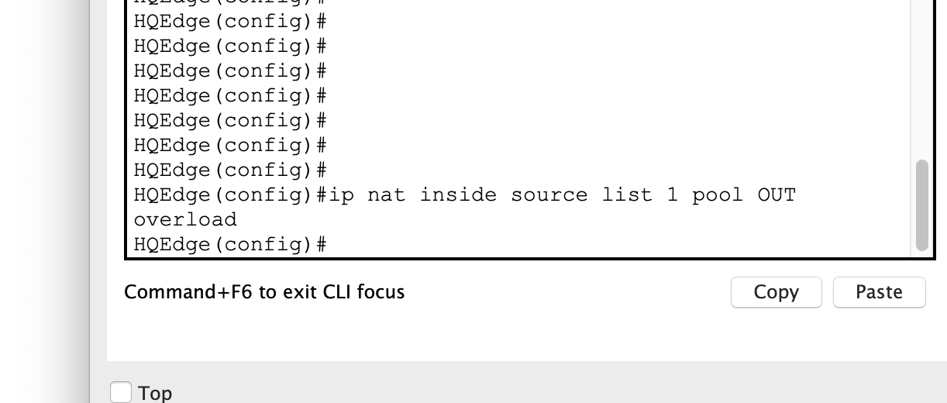



Layer 3 switching – routing and switching all in one

(3560 switch )

Create *switch/ vlan* on layer 3 switch ie

Sw1(config)# Hostname

Sw1(config)#vlan 10

Sw1(config)# vlan 20

Sw1(config)# do show vlan

Sw1(config)# Interface<> //what ever interface

Sw1(config-int)# switchport mode access

Sw1(config-int)# switchport access vlan <#10>. // in this case 10

Sw1(config)# Interface<> //what ever different interface

Sw1(config-int)# switchport mode access

Sw1(config-int)# switchport access vlan <#20>. // in this case 20

Sw1(config)# int vlan <10>

Sw1(config-if)# ip address <ip><subnet>

Sw1(config-if)# no shut

Sw1(config)# int vlan <20>

Sw1(config-if)# ip address <ip><subnet>

Sw1(config-if)# no shut

Sw1#show run

Sw1(config)# ip routing. // this will enable routing – pretty simple

Sw1(config)# Interface<> //routing interface

Sw1(config-if)# no switchport // line protocol will change states

Sw1(config-if)# ip add <ip><sub> //after the preceding command you can apply an ip to the   
 interface.

Sw1(config-if)# no shut

Sw1(config)# ip default-gateway <ip add of port>

Layer 3 routing on 3560

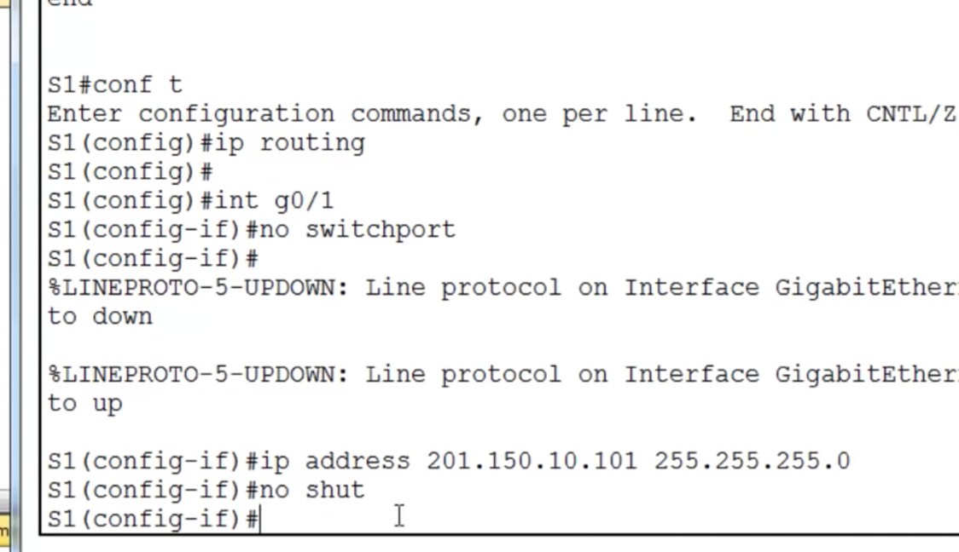

***Class 7***  *- DHCP - March 12th 2020*

Dynamic Host control protocol – assigns IP address to devices that do not have one.

**DHCP commands**

* **Router# Int <port>**
* **Router(config-if)# ip add <ip add> <subnet>**
* **Router(config-if)# no shut**
* **Router(config)# Ip dhcp excluded-address <ip address range start> <IP address range end>**
* **Router(config)# Ip dhcp pool NAMEOFPOOL**
* **Router(dhcp-config)# Network <ip address(ie 192.168.1.0)> <subnet mask(ie. 255.255.255.0)>**
* **Router(dhcp-config)# Default router <ip address> (same ip address as the interface of the router)**

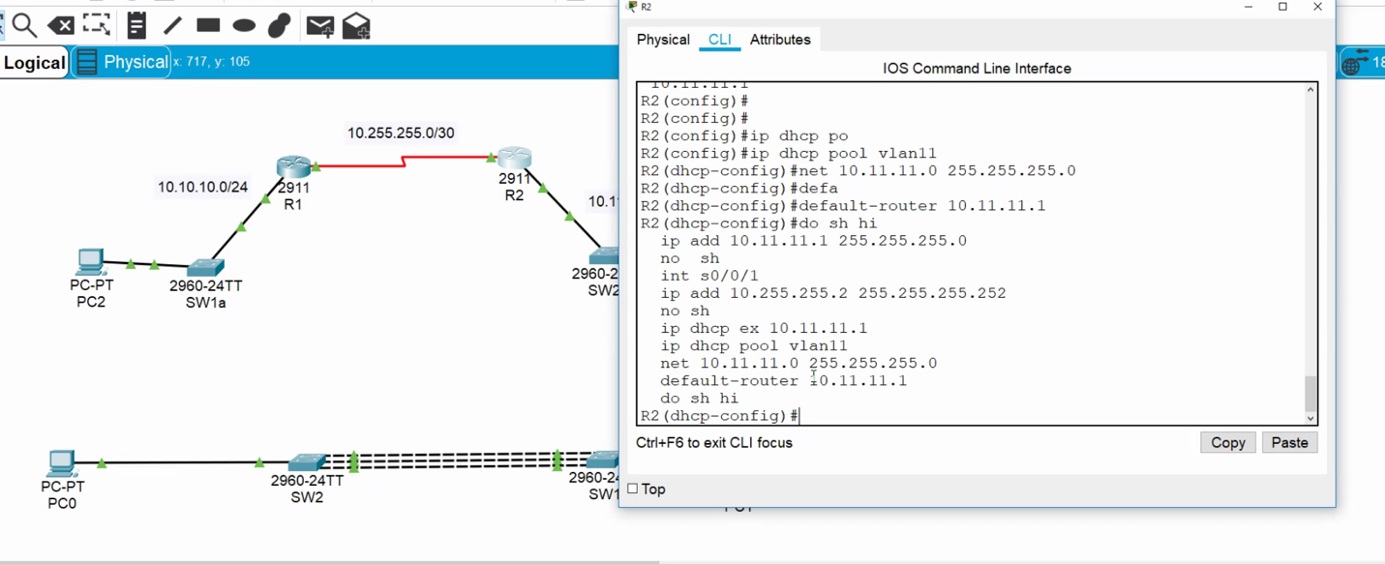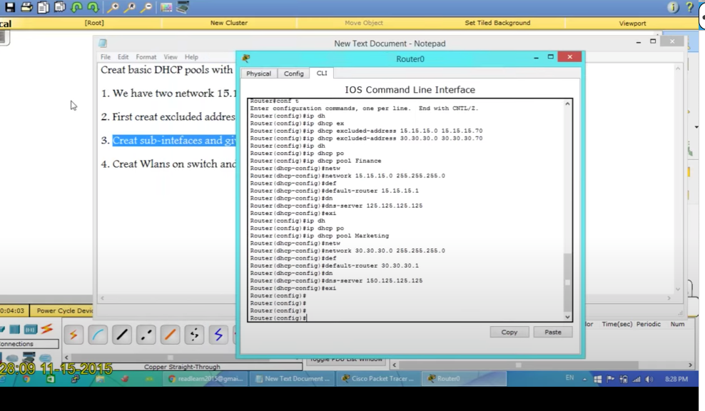

*Spring Break Extended One week*

***Class 8***  *Recap And Multi Protocol Switches- April 2nd 2020*

*ONLINE LEARNING DUE TO CORONA VIRUS*

Class 9 - April 9, 2020

1. Using switches(2960) multiple crossover cables in between switches

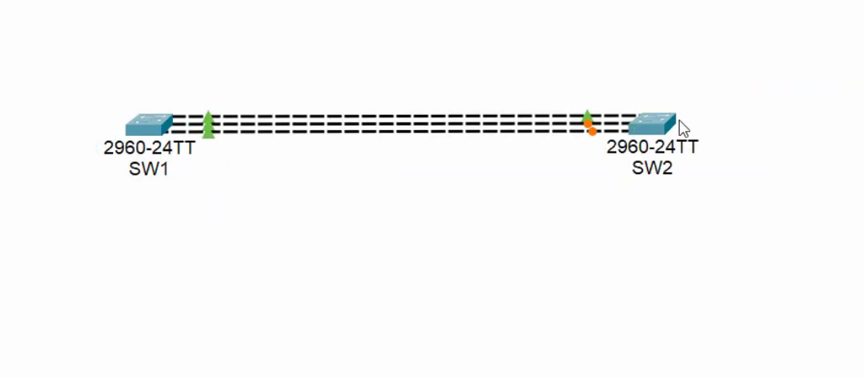

Channel grouping – logical grouping of ports that decides which port to use… Can use up to 8 ports …. Can be configured on both routers and switches:

Command:

int range fa0/1-6

Switch port mode trunk

channel-group 1 mode on

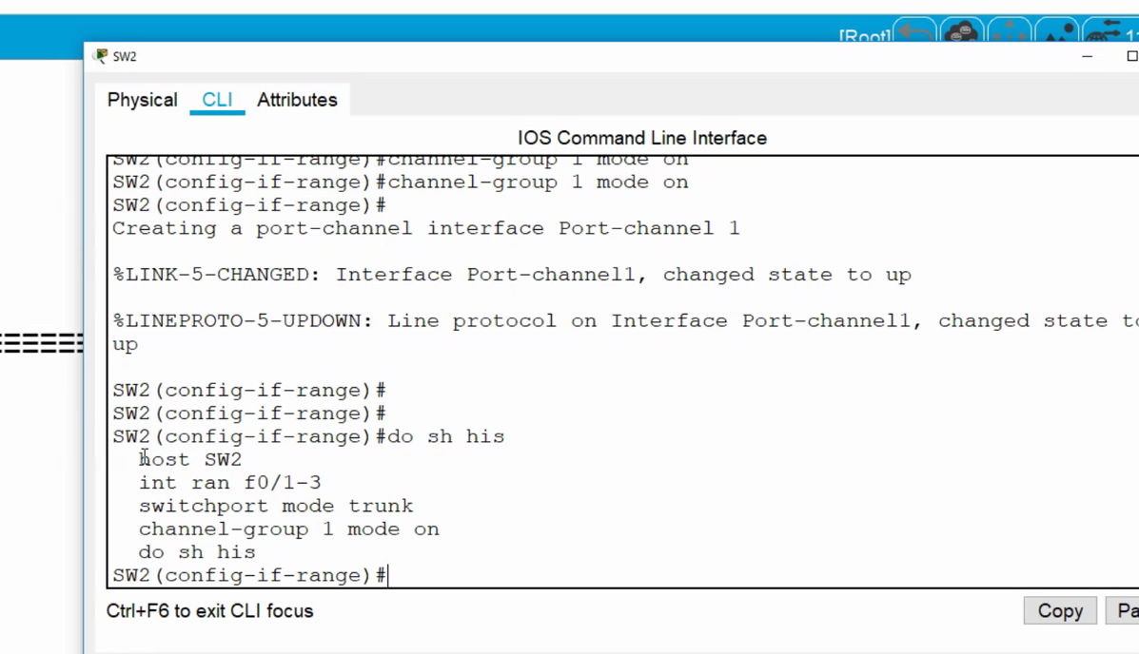

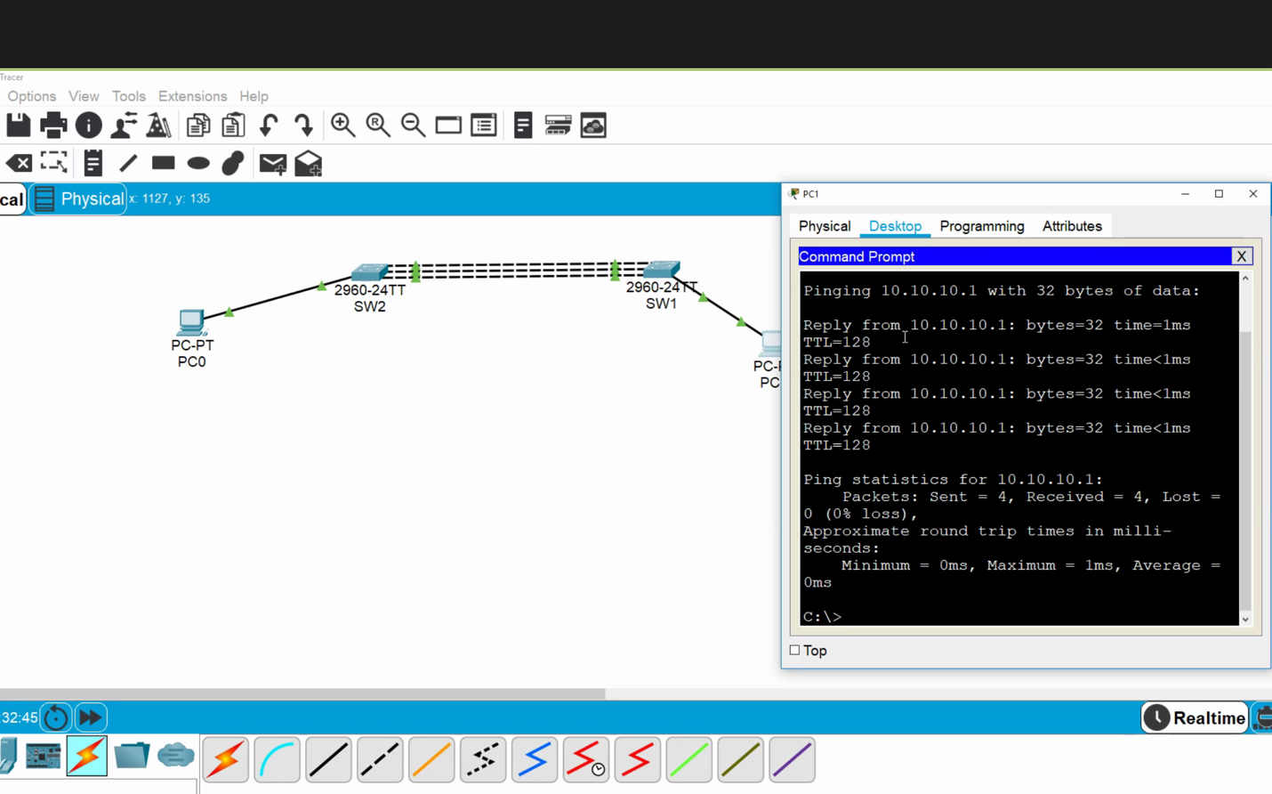

If a connection is cut the other lines will pick up the volume, however the bandwidth will be reduced.

Also, not shown, you can create multiple channel groups switched connections to other switches (like three switches in a triangle with 3 connections in-between each)

1. Setup authentication between devices

Basics:



**Router 1 PPP---------------------------------------------------------------------------------------------------**

User name has to be the name of the router than we are connecting to.

Commands in Router 1:

Router1(Config)# Username *‘Router2’* password *‘cisco’*

*Within the port connected to the router that is being connected for PPP:*

Router1(Config)# *Int <port>*

*Router1(config-if)# encapsulation ppp*

*[status will change to down because of mismatch between routers- default encapsulation is HDLC]*

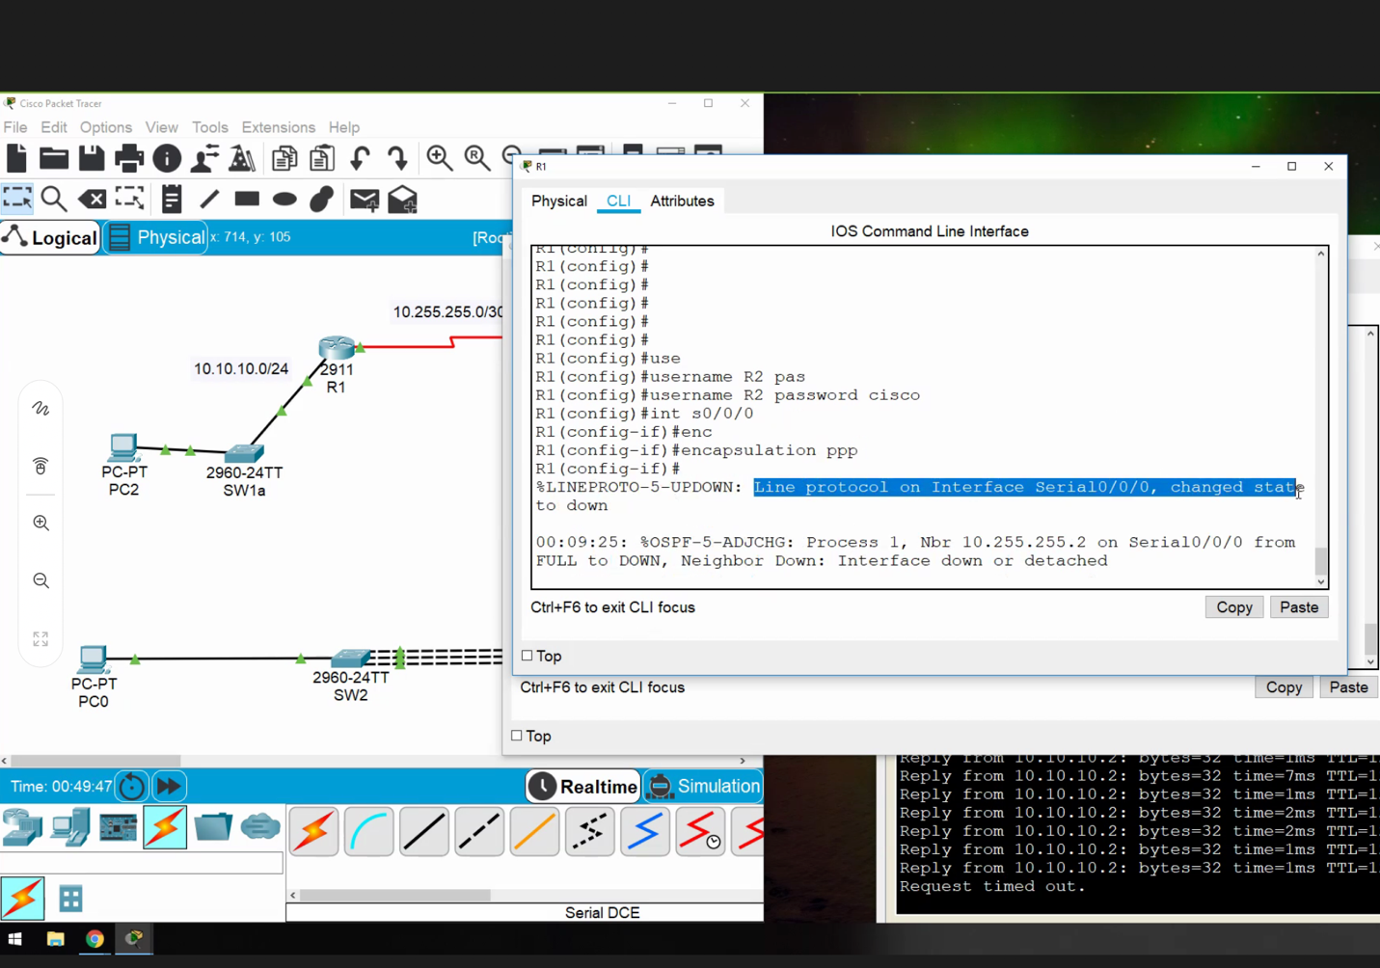

After we create encapsulation we have to specify the type of PPP (PAP is antiquated).

Command for hand shake:

*Router1(config-if)#* **ppp authentifcation chap**

**Router 2 PPP---------------------------------------------------------------------------------------------------**

Commands in Router 2:

Router2(Config)# Username *‘Router1’* password *‘cisco’*

*Within the port connected to the router that is being connected for PPP:*

Router2(Config)# *Int <port>*

*Router2(config-if)# encapsulation ppp*

*[status will change to up because two router match]*

*Router1(config-if)#* **ppp authentifcation chap**

**[Ping from one side to the other to validate]**

Must enter user name of router conneted to, the password must be the same!!!

Advance topic, you can use PPP to encrypt traffic over another network.

Class 10 - April 16, 2020

Get rid of errors pop ups

Line console 0

Logging Synchronous

(or)

No Logging console

*Redistribute* command – redistributing routes

Send other routing protocols through a router

New routing protocol: eigrp

Command: (from configure ) ‘router eigrp 1’

EIGRP has a clear speed advantage when compared to OSPF. OSPF runs every 30 seconds. EIGRP is a Cisco proprietary protocol that is more instantaneous.

